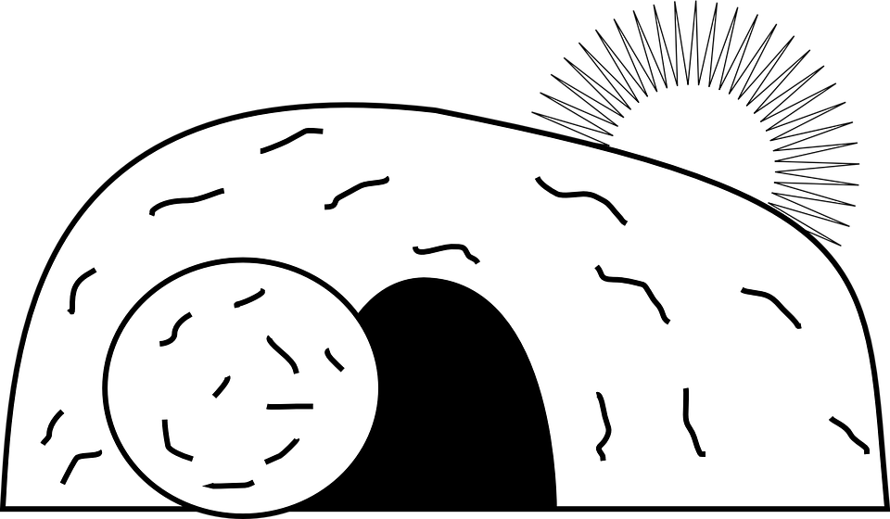

**What:** Investigate the cause of Jesus’ empty tomb in this Resurrection themed Escape Room. An Escape Room is a puzzle challenge where players are “locked” in a room and must solve a series of clues as a team in order to successfully “escape” within the time frame.   
  
**When:** Reserve a 2-hour time slot for you, your group, or family (first contact, first served basis).

* Thursday, April 9 - 6:00pm-8:30pm
* Friday, April 10 - 1:00pm-8:15pm
* Saturday, April 11 - 1:00pm-8:15pm

**Where:** ​Red Bridge Baptist Church; 4901 E. Red Bridge Rd., KCMO 64137  
  
**Cost:** Suggested donation of $3 per player; chaperons of teen groups are free; $12 max for families with more than 4 family members.  
  
**View Available Time Slots/Register/Questions/Info:** [www.networkerstec.com/escape.html](https://www.networkerstec.com/escape.html)

or Hanna (816-392-0094; info.networkerstec@gmail.com)

**ESCAPE ROOM**

**The Case of the Empty Tomb…**