“Theory #3—Hallucination” Clues

Cut and put inside the “FALSE” envelope in Briefcase #2 | Theory #3—Hallucination  True or False?  Directions:  - Read the poem below.  (1) Over 500 saw with their eyes.  (2) And when the disciples touched him, they realized,  That he wasn’t dead-  (3) But since he was fed,  (4) They knew the one they walked with was truly alive.  - Find the 4 objects that coordinate with the four numbered lines of the poem that would demonstrate that the disciples were not hallucinating.  - The combination numbers are hidden on the objects and the order of the code corresponds with the order of the poem and hidden numbers on the objects.
Cut and glue on the front of Briefcase #3 | Theory #3 — Hallucination
Cut and put in the envelope labeled “TRUE” in Briefcase #3 | Sorry, wrong answer! Try again.

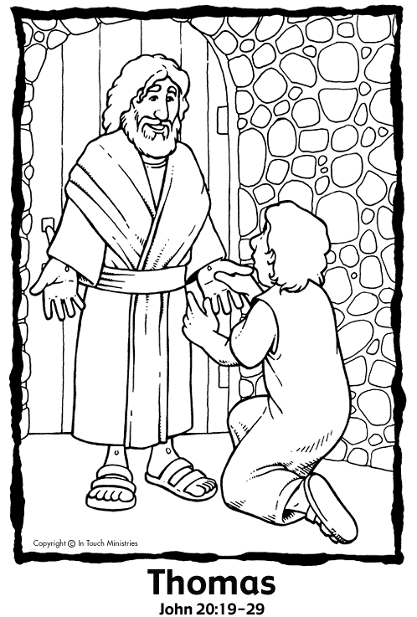
(NOTE: This is a picture that you can use for line 2 of the poem-"And when the disciples touched him...". It is a different picture from the one in the photo on the webpage but the idea is the same. *Cut this note off before using the picture.*

#3

"Thomas" illustration Copyright © IN TOUCH MINISTRIES - In Touch Interactive Dept. Used with permission - In Touch Ministries, P.O. Box 7900, Atlanta, GA 30357 - All rights reserved. www.intouch.org – Coloring Picture from: https://sermons4kids.com/thomas-jesus-colorpg-2.htm

