“Theory #4—Added Later” Clues

Cut and glue on the front of Briefcase #4 | Theory #4 — Added Later
Cut and put in the envelope labeled “TRUE” in Briefcase #4 | Sorry, wrong answer! Try again.

(NOTE: Cut the below clue picture on the solid line; you could also cut the clue into more pieces if you would like so that participants are looking for more pieces. If you do so, be sure to write “#4” on the additional pieces to show that the pieces are part of Theory #4. Place one part of this clue in the “FALSE” envelope” in Briefcase #3. And hide the other piece(s) somewhere in the room.)

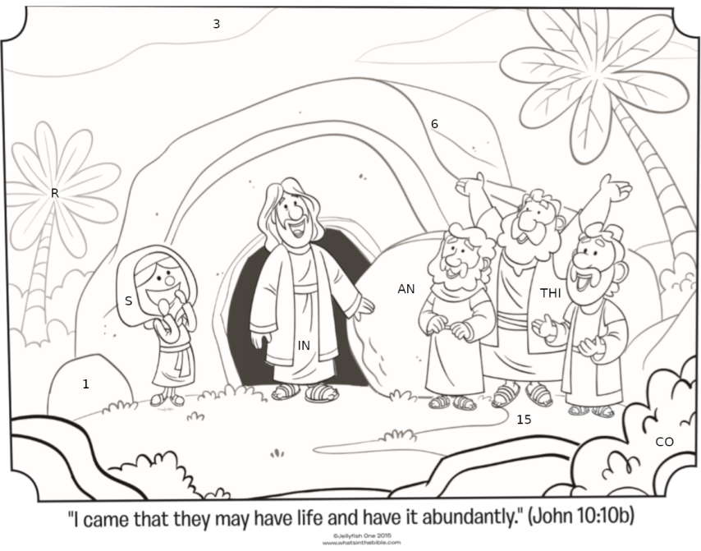
#4
#4

Picture from: www.whatsinthebible.com
©JellyFish One 2015

1 | 2 | 3 | 4 | 5 | 6 | 7 | 8 | 9 | 10
In box 3, write the letter that is on the tree.
In box 5, write the letters that are on the disciple.
In box 7, write the letter that is on the girl’s head covering.
In box 9, write the number that is in the sky and then write a “—“ (dash) after the number.
In box 1, write the number that is on rock next to the girl.
In box 4, write the letters that are on Jesus.
In box 6, write the letters that are on the stone by Jesus’ hand.
In box 8, write the number under the disciples feet and then write a “:” (colon) after the number.
In box 10, write the number that is on tomb.
In box 2, write the letters that are in the bush.
Now look up the Scripture address in a Bible.
The lock combination for briefcase #4 is the order of the shapes above + the shape found at the mystery Scripture.

