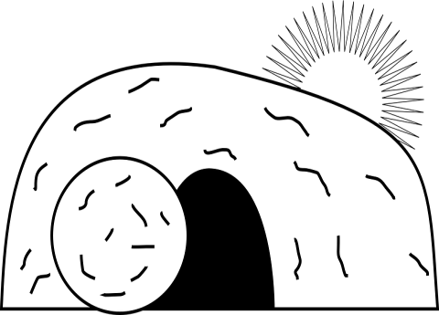
ESCAPE ROOM:
The Case of the Empty Tomb

What: Investigate the cause of Jesus’ empty tomb in this Resurrection themed Escape Room. An Escape Room is a puzzle challenge where players are “locked” in a room and must solve a series of clues as a team in order to successfully “escape” within the time frame.
When: Reserve a 2-hour time slot for you, your group, or family (first contact, first served basis). See specific time slots on website.
- Thursday, April 9 - 6:00pm-8:30pm
- Friday, April 10 - 1:00pm-8:15pm
- Saturday, April 11 - 1:00pm-8:15pm
Where: ​Red Bridge Baptist Church;
4901 E. Red Bridge Rd., KCMO 64137
Cost: Suggested donation of $3 per player; chaperons of teen groups are free; $12 max for families with more than 4 family members.
Register/Questions/Info: www.networkerstec.com/escape.html
or Hanna (816-392-0094; info.networkerstec@gmail.com)

ESCAPE ROOM:
The Case of the Empty Tomb

What: Investigate the cause of Jesus’ empty tomb in this Resurrection themed Escape Room. An Escape Room is a puzzle challenge where players are “locked” in a room and must solve a series of clues as a team in order to successfully “escape” within the time frame.
When: Reserve a 2-hour time slot for you, your group, or family (first contact, first served basis). See specific time slots on website.
- Thursday, April 9 - 6:00pm-8:30pm
- Friday, April 10 - 1:00pm-8:15pm
- Saturday, April 11 - 1:00pm-8:15pm
Where: ​Red Bridge Baptist Church;
4901 E. Red Bridge Rd., KCMO 64137
Cost: Suggested donation of $3 per player; chaperons of teen groups are free; $12 max for families with more than 4 family members.
Register/Questions/Info: www.networkerstec.com/escape.html
or Hanna (816-392-0094; info.networkerstec@gmail.com)

