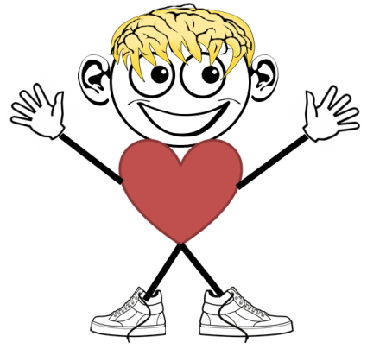
Herman/Hummin’ Worksheet
Instructions: Write a script/outline for how you would teach a verse or song using the parts of Herman/Hummin. (Parts include: Eyes/Introduction, Ears/Presentation, Brain/Explanation, Heart/Application, Hands and Feet/Repetition, and Mouth/Recitation.)
_____________________________________________________________________
______________________________________________________________________
______________________________________________________________________
______________________________________________________________________
______________________________________________________________________
______________________________________________________________________
______________________________________________________________________
______________________________________________________________________
______________________________________________________________________
______________________________________________________________________
______________________________________________________________________
______________________________________________________________________
______________________________________________________________________
______________________________________________________________________
______________________________________________________________________
______________________________________________________________________
______________________________________________________________________
_____________________________________________________________________
______________________________________________________________________
_____________________________________________________________________
______________________________________________________________________
_____________________________________________________________________
______________________________________________________________________
_____________________________________________________________________
______________________________________________________________________
_____________________________________________________________________

